**Kavya_Wipro_Training_Batch3_Satinnder**

**Day-1[14-06-24] 1.Comparsion between Dual-core VS Quad-core**

|  |  |
| --- | --- |
| **Dual-core** | **Quad-core** |
| Dual-core means a processor with two separate cores, Handles basic tasks well, but may struggle with heavy multitasking or demanding applications | Quad-core means a processor with four separate cores. Capable of handling more tasks simultaneously without significant slowdowns. |
| Slower for tasks that benefit from multiple cores, like video editing or 3D rendering. | Faster for tasks that utilize multiple cores, offering quicker video rendering or complex calculations. |
| Generally consumes less power, leading to better battery life in laptops and lower electricity bills in desktops. | Consumes more power due to additional cores, which may reduce battery life in laptops and increase electricity usage in desktops. |
| Limited multitasking capability due to fewer processing cores. | Better multitasking performance due to more processing cores. |
| Smoothly runs web browsing, document editing, and light gaming. | Smoothly handle gaming while streaming music, editing photos, and browsing the internet simultaneously. |

**2.Comparsion between i5 VS i7**

|  |  |
| --- | --- |
| **i5** | **i7** |
| Good for everyday tasks and moderate multitasking. | Better for heavy multitasking and demanding tasks. |
| Usually 4 to 6 cores. | Usually 4 to 8 cores |
| High base speeds, can handle most applications well. | Higher base and boost speeds, ideal for intensive tasks. |
| Some models have Hyper-Threading. | Most models have Hyper-Threading for better multitasking. |
| Good for gaming with decent performance. | Excellent for gaming with higher frame rates. |
| Adequate for photo and video editing. | Superior for professional-grade photo and video editing. |
| More affordable and offers good value. | More expensive, reflecting higher performance capabilities. |

**Day – 2 [17.06.24]**

**1.ASCII Code for arrows up,down,right,left?**

|  |  |  |
| --- | --- | --- |
| Left Arrow | ← | U+02190 |
| Up Arrow | ↑ | U+02191 |
| Right Arrow | → | U+02192 |
| Down Arrow | ↓ | U+02193 |

**2.IP address from /11 to /32?**

/8 – 255.0.0.0

/9 – 255.128.0.0

/10 – 255.192.0.0

/11 - 255.224.0.0

/12 - 255.240.0.0

/13 - 255.248.0.0

/14 -255.252.0.0

/15 -255.254.0.0

/16 - 255.255.0.0

/17 - 255.255.128.0

/18 - 255.255.192.0

/19 - 255.255.224.0

/20 - 255.255.240.0

/21 - 255.255.248.0

/22 - 255.255.252.0

/23 - 255.255.254.0

/24 - 255.255.255.0

/25 - 255.255.255.128

/26 - 255.255.255.192

/27 - 255.255.255.224

/28 - 255.255.255.240

/29 - 255.255.255.248

/30 - 255.255.255.252

/31 - 255.255.255.254

/32 - 255.255.255.255

**3.What is the subnet mask and network address for ip – 70.49.72.1?**

subnet mask – 255.255.255.0  
Network address – 70.49.72.0

**4.Answer the following questions?**

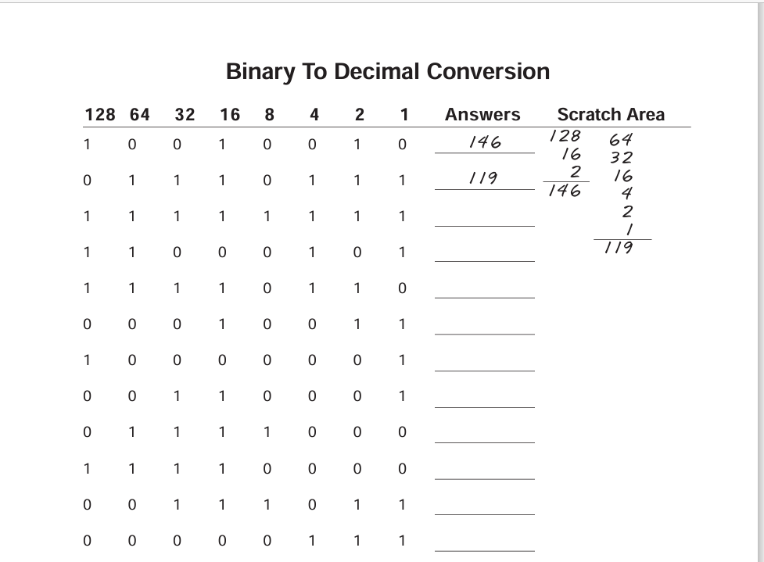

🡪 3 – 255

4 – 197

5 – 246

6 – 19

7 – 129

8 – 49

9 – 120

10 – 240

11 – 59

12 - 7

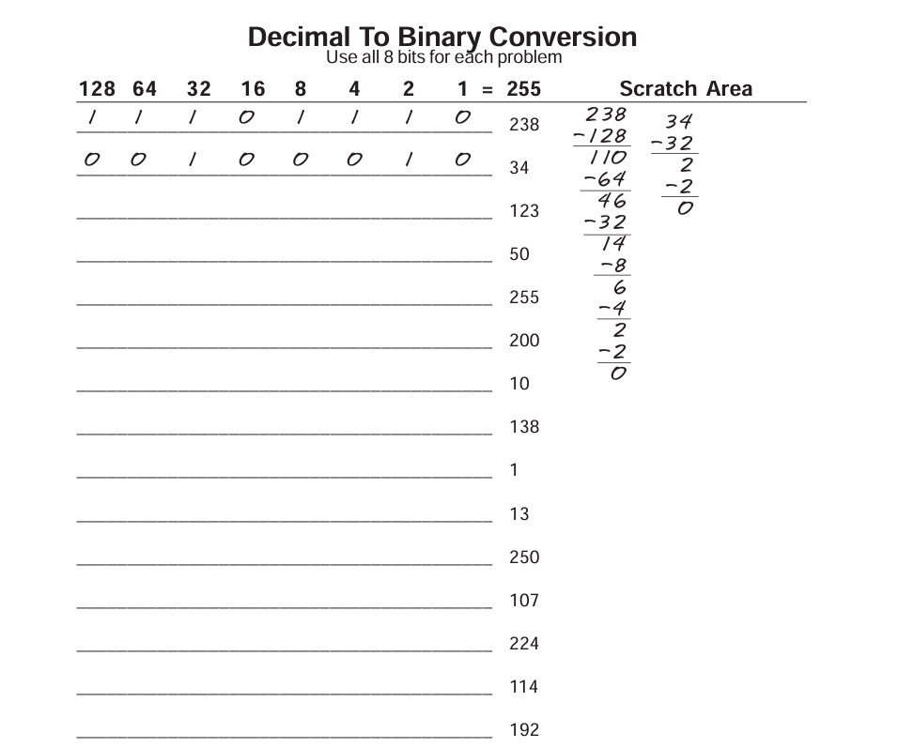

🡪 3 – 01111011

4 – 00110010

5 – 11111111

6 – 11001000

7 – 00001010

8 – 01001010

9 – 00000001

10 – 00001101

11 – 11111010

12 – 01101011

13 – 11100000

14 – 01110010

15 - 11000000

-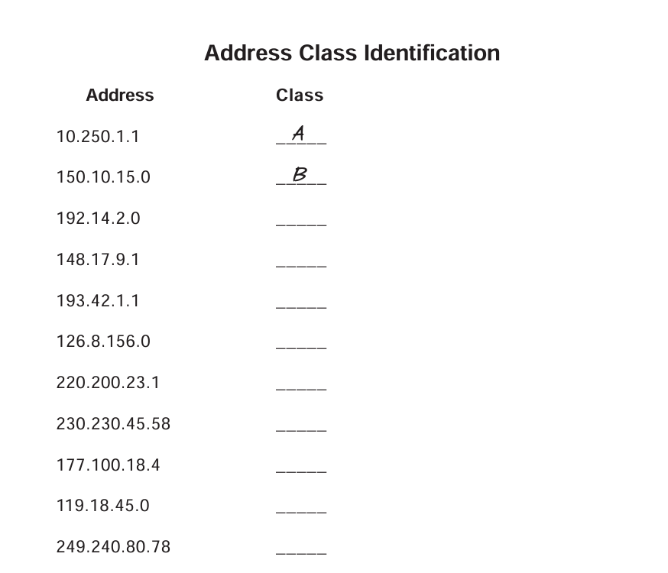

🡪 **Class A:** 1.0.0.0 to 127.255.255.255  
**Class B:** 128.0.0.0 to 191.255.255.255  
**Class C:** 192.0.0.0 to 223.255.255.255  
**Class D:** 224.0.0.0 to 239.255.255.255  
**Class E:** 240.0.0.0 to 255.255.255.255

🡪3 – C

4 – B

5 – C

6 - A

7- C

8 – D

9 – B

10 – A

11 – E

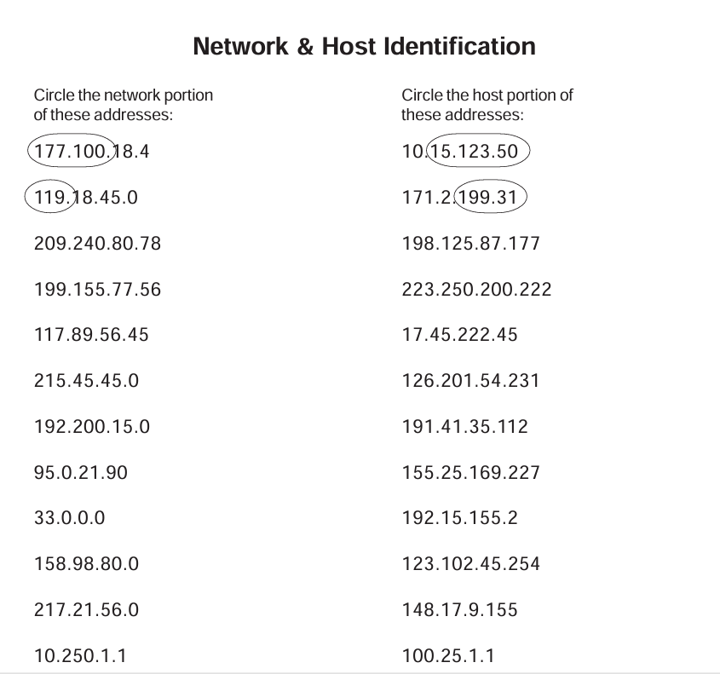

209.240.80 – network address 177 – host address

199.240.80 - network address 222 – host address

177.89 - network address 45.222.45 - host address

215.45.45 - network address 201.54.231 - host address

192.200.15 - network address 35.112 - host address

95 - network address 169.227 - host address

33 - network address 2 - host address

158.98 - network address 102.45.254 - host address

217.21.56 - network address 9.155 - host address

10 - network address 25.1.1 - host address

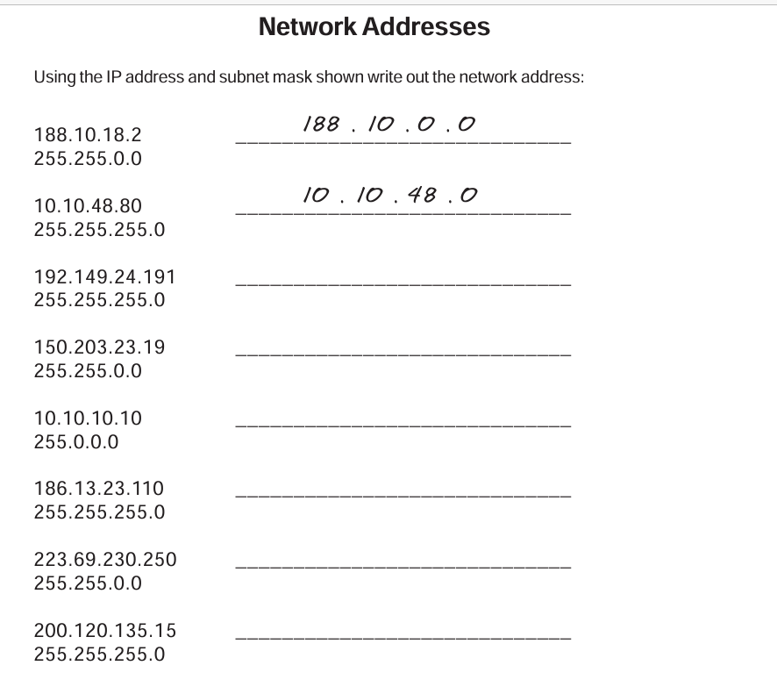

🡪 3 - 192.149.24.0

4 - 150.203.0.0

5 - 10.0.0.0

6 - 186.13.23.0

7 - 223.69.0.0

8 - 200.120.135.0

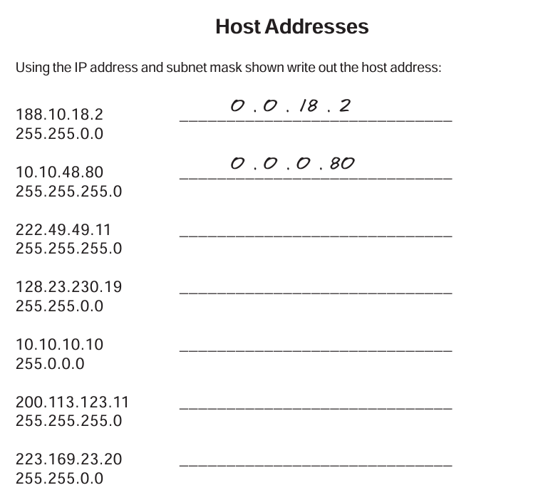

🡪 3 – 0.0.18.2

4 – 0.0.0.80

5 – 0.0.0.11

6 - 0.0.230.19

7 – 0.10.10.10

8 – 0.0.0.11

9 – 0.0.23.20

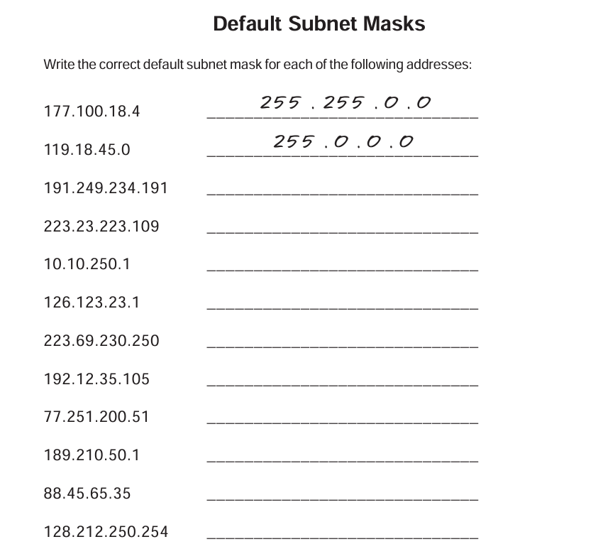

->**Default Subnet Masks are**

|  |  |
| --- | --- |
| **Class A** | **255.0.0.0** |
| Class B | 255.255.0.0 |
| Class C | 255.255.255.0 |
|  |  |

* 3 – (Class B) 255.255.0.0  
  4 – (Class C)255.255.255.0

5 – (Class A)255.0.0.0

6 – 255.0.0.0

7 – 255.255.255.0

8 – 255.255.255.0

9 – 255.0.0.0

10 – 255.255.0.0

11 – 255.0.0.0

12 – 255.255.0.0

**DAY-3 [18.06.24]**

**1. Connect Two Routers**

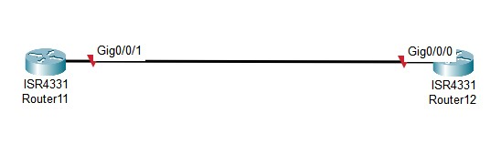

**2.Connect Router with a Switch**

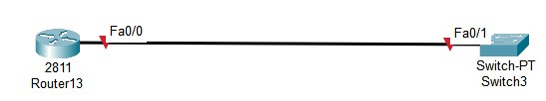

**3. Connect Router with PC**

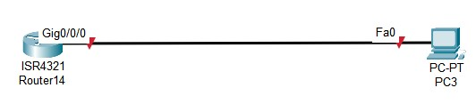

**4.** **Connect PC with a switch**

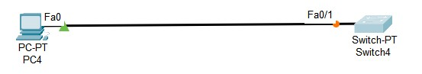

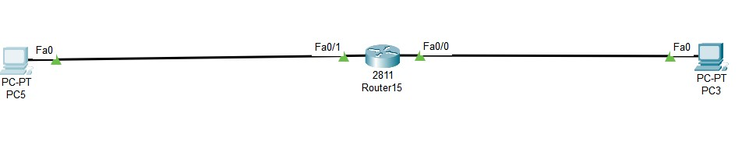 **Router to PC3:**

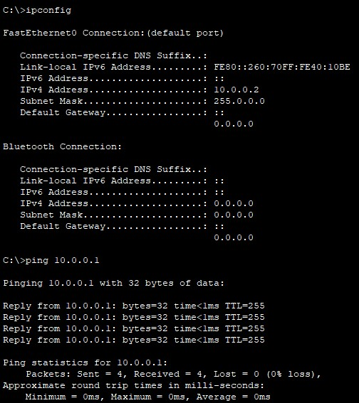

**Router to PC5 :**

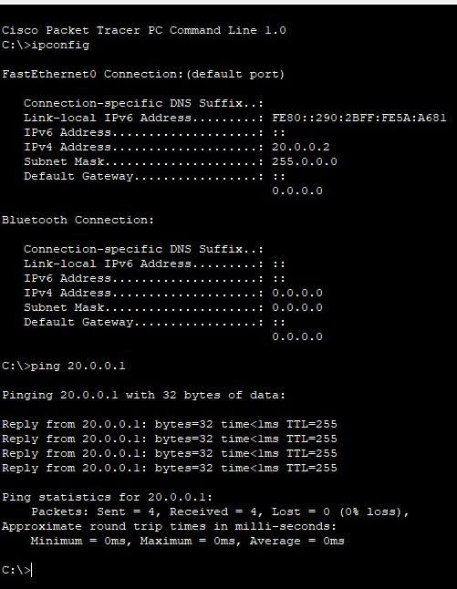

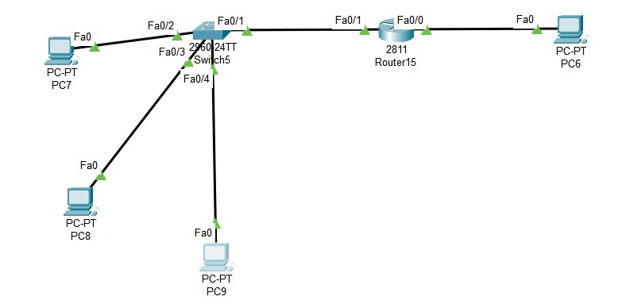

|  |
| --- |
|  |

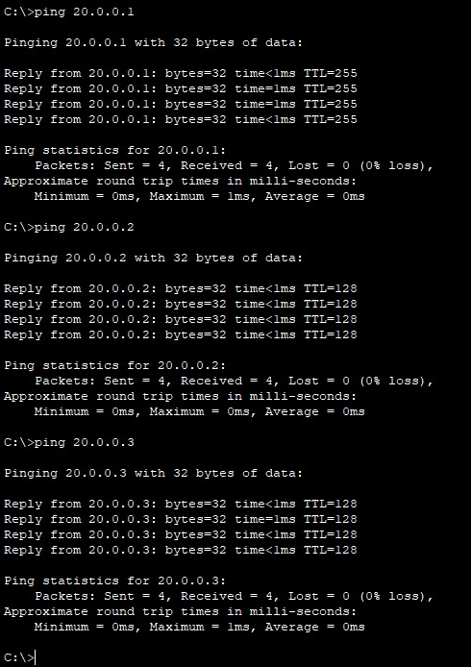

|  |  |  |
| --- | --- | --- |
| **Connection** | **R15 Fa0/0** | **R15 Fa0/1** |
| **PC6** | Connected | Connected |
| **PC7** | Connected | Connected |
| **PC8** | Connected | Connected |
| **PC9** | Connected | Connected |

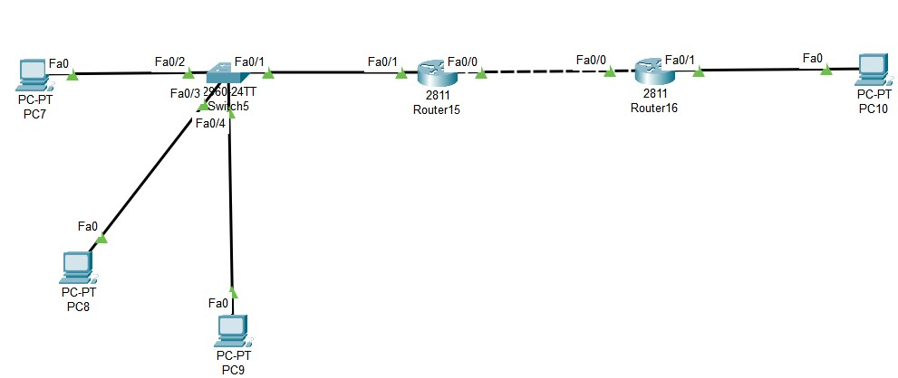

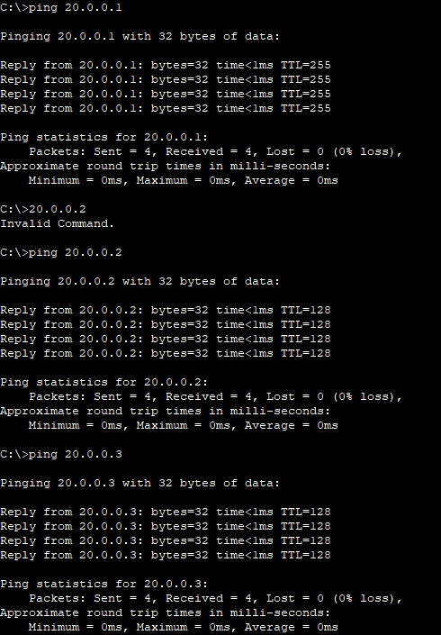

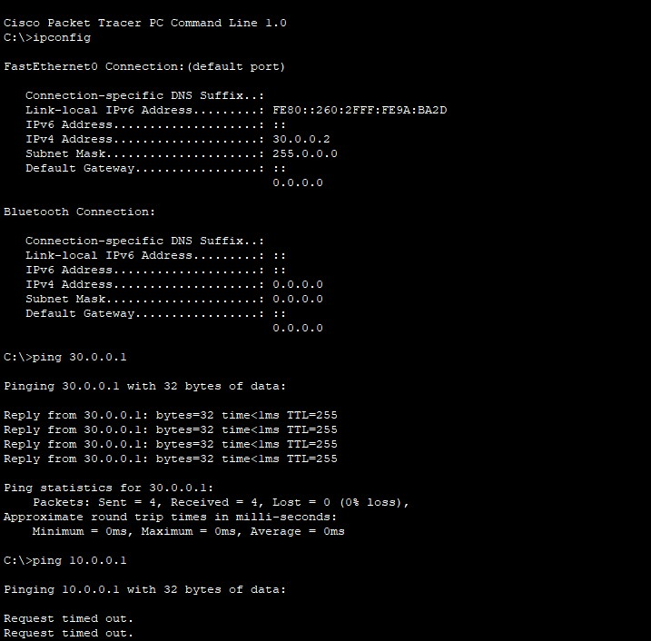

|  |  |  |  |  |
| --- | --- | --- | --- | --- |
| **Connection** | **R15 Fa0/1** | **R15 Fa0/0** | **R16 Fa0/1** | **R16 Fa0/0** |
| **PC7** | Connected | Connected | Not Connected | Not Connected |
| **PC8** | Connected | Connected | Not Connected | Not Connected |
| **PC9** | Connected | Connected | Not Connected | Not Connected |
| **PC10** | Not Connected | Not Connected | Connected | Connected |

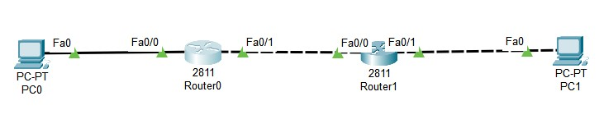

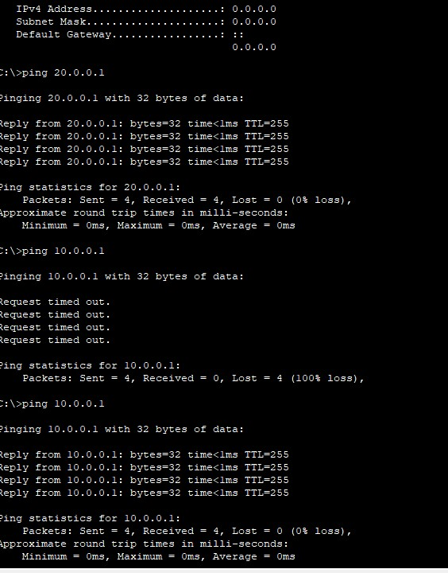**PC0:**

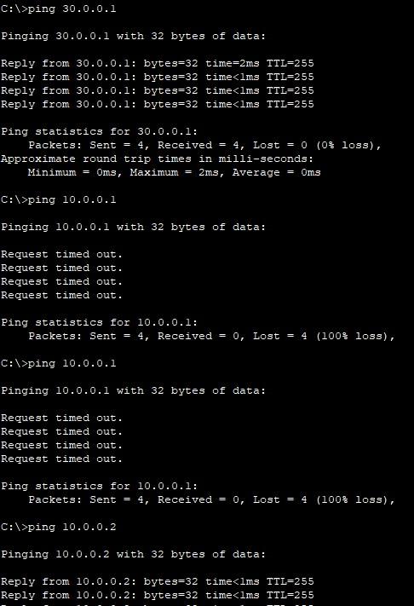

|  |  |  |  |  |
| --- | --- | --- | --- | --- |
| **Connection** | **R0 Fa0/0** | **R0 Fa0/1** | **R1 Fa0/0** | **R1 Fa0/1** |
| **PC0** | Connected | Connected | Not Connected | Not Connected |
| **PC1** | Not Connected | Not Connected | Connected | Connected |

**Day – 4 [19.06.24]**

**Static Routing** 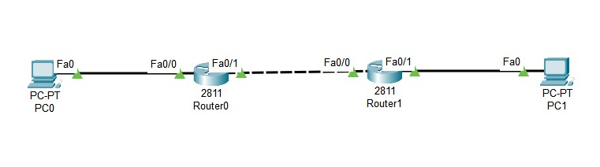 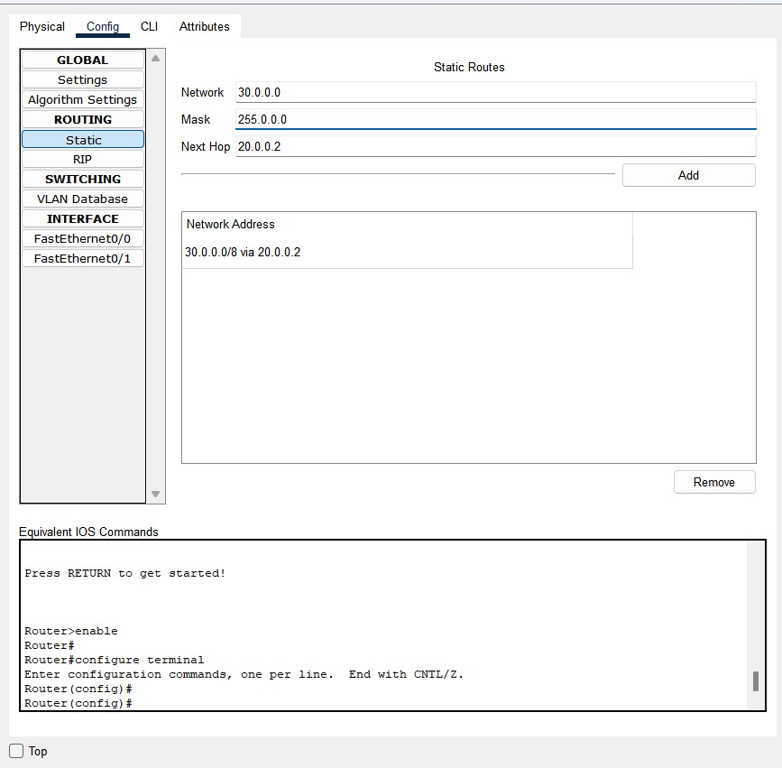

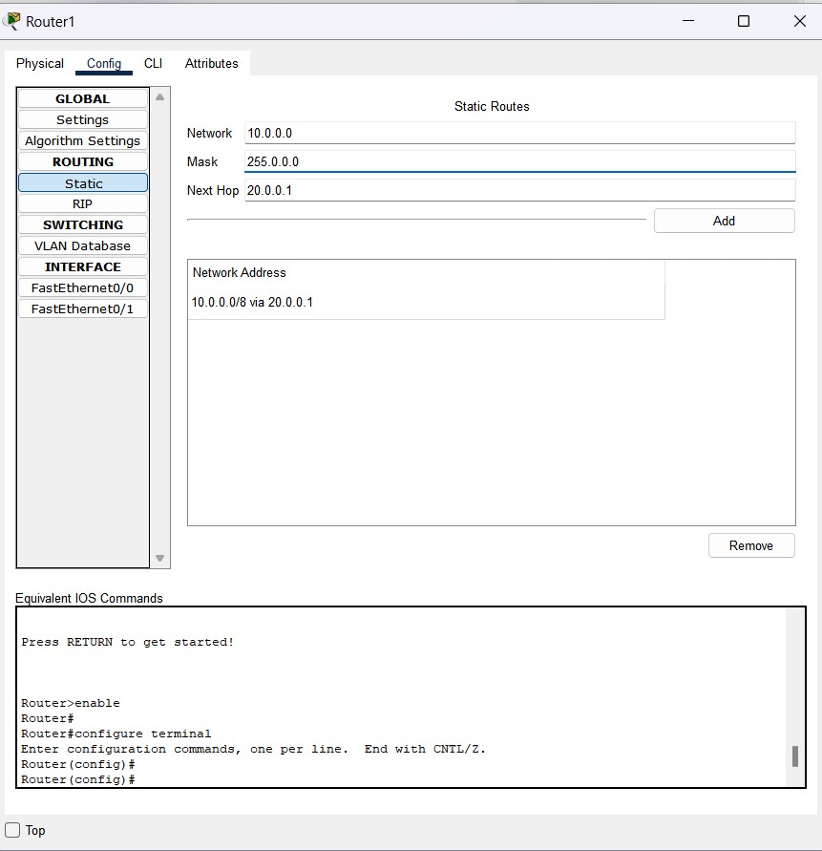

**PC0:**

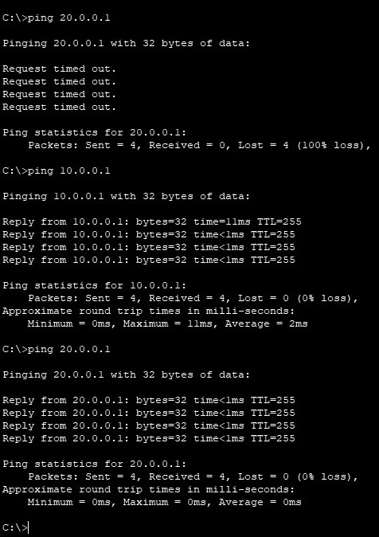

**PC1:**

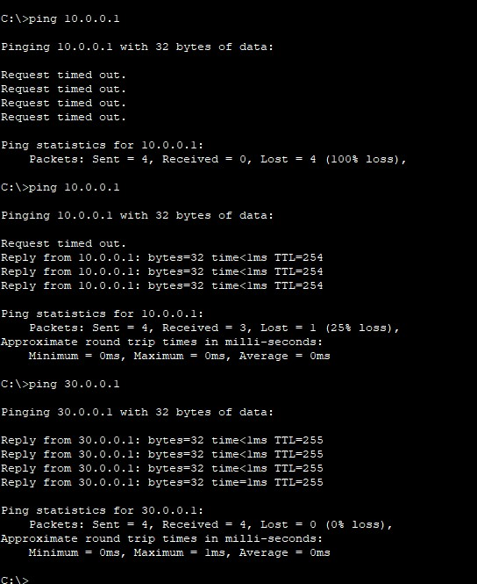

**Day – 5 [20.06.24]**

**OSI MODEL DIAGRAM:**

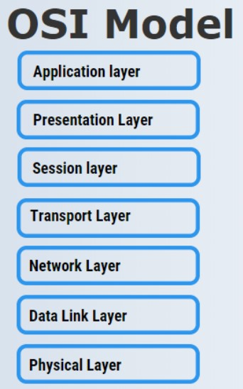

**Application Layer:** Provides network services directly to user applications, such as email, web browsing, and file transfer.

**Presentation Layer:** Ensures data is presented in a readable format by handling data encryption, compression, and formatting.

**Session Layer:** Manages communication sessions, allowing devices to establish, maintain, and terminate connections.

**Transport Layer:** Provides reliable data delivery by establishing, maintaining, and terminating connections between devices.

**Network Layer:** Routes data packets across multiple networks, determining the best path for delivery using logical addressing.

**Data Link Layer:** Manages data transfer between directly connected devices, ensuring error-free transmission and addressing.

**Physical Layer:** Handles physical connections and raw data transmission over mediums like cables or fiber optics.

|  |  |  |  |
| --- | --- | --- | --- |
| **Layers** | **Protocols** | **Port Numbers** | **services** |
| **Application** | HTTP,FTP, SMTP,POP3, IMAP, Telnet | HTTP (80), HTTPS (443), FTP (20, 21), SMTP (25), POP3 (110), IMAP (143), Telnet (23) | Email, web browsing, file transfer, remote login |
| **Presentation** | SSL/TLS, ASCII, JPEG, GIF, PNG | SSL/TLS (443), ASCII (7) | Data encryption, data compression, data formatting |
| **Session** | NetBIOS, PPTP, RPC | NetBIOS (137-139), PPTP (1723), RPC (Remote Procedure Call) | Session management, dialog control, synchronization |
| **Transport** | TCP, UDP | **TCP**-HTTP (80), HTTPS (443), FTP (20, 21), SMTP(25),POP3(110), IMAP (143),SSH(22), Telnet(23)  **UDP**-DNS(53),DHCP(67,68),SNMP(161), TFTP(69),NTP(123) | Reliable data delivery, error-checking, flow control |
| **Network** | IP, ICMP, ARP | ICMP (Internet Control Message Protocol), ARP (Address Resolution Protocol) | Logical addressing, routing, traffic control |
| **Data Link** | Ethernet, PPP, HDLC, LLC | **----------------** | Error detection and correction, framing |
| **Physical** | Ethernet, Wi-Fi, Fiber optics, USB, Bluetooth | **--------------------** | Physical transmission of data |

Top of Form

Bottom of Form

**Difference between OSI Model VS TCP/IP Model**

|  |  |
| --- | --- |
| **OSI Model** | **TCP/IP Model** |
| It stands for **Open System Interconnection.** | It stands for **Transmission Control Protocol.** |
| OSI Model has been developed by ISO(International standard organization). | It was developed by ARPANET(Advanced Research Project Agency Network). |
| **It comprises seven layers**  ->Application  ->Presentation  ->Session  ->Transport  ->Network  ->Data link  ->Physical | **It comprises of four layers**  ->Application  ->Transport  ->Internet  ->Network Interface |
| It follows a vertical approach. | It follows a horizontal approach. |
| In this model, the network layer provides both connection-oriented and connectionless service. | The network layer provides only connectionless service |
| Protocols in the OSI model are hidden and can be easily replaced when the technology changes. | In this model, the protocol cannot be easily replaced. |
| The usage of this model is very low. | This model is highly used. |
| It provides standardization to the devices like router, motherboard, switches, and other hardware devices. | It does not provide the standardization to the devices. It provides a connection between various computers. |
| An OSI Model is a reference model, based on which a network is created. | The TCP/IP is the implementation of the OSI Model. |
| The smallest size of the OSI header is 5 bytes. | The smallest size of the TCP/IP header is 20 bytes. |

**Using NAT:**

